HGV Movement Strategy

- Introduction
The majority of roads in urban areas were not built with modern HGVs in mind. As a result of this they often create a variety of issues for local communities and other road users. However the delivery of goods is essential to modern life with all of society dependent on them to some degree or other.
Whilst measures can be put in place to limit their impact on local communities, this is often very difficult without impacting significantly on the distribution process. This then has implications for the freight industry, the wider business sector as well as customers and communities as a whole. Without new infrastructure there will always be a trade off in terms of granting HGVs the access they need to deliver goods and the subsequent impact this has on communities.
Fortunately, the opening of the new link road from Junction 34 of the M6 linking Morecambe and the town and port of Heysham, provides an ideal opportunity to review current HGV access and determine how these can be better managed to secure improvements for both HGV operators and their clients as well as the wider community.
This strategy aims to do this and is structured as follows. Firstly it places the need for a strategy in the context of the draft Lancaster District Highways and Transport Masterplan and the Development Consent Order requirements for the link road. It then describes the geographical scope of the strategy. Following on from this it gives more detail in terms of the specific areas of the local network affected and describes how the opening of the link road provides significant opportunities to meet the objectives of the draft Lancaster District Highways and Transport Masterplan. Accessibility issues are also discussed before recommendations are made in relation to specific areas of the network. This is then followed with narrative on the implications for enforcement, diversionary routes and abnormal loads before concluding with a series of recommendations that will pave the way for subsequent Traffic Regulation Orders. Appendices are included that illustrate both the permitted principal roads as well as the roads that will be subject to weight restrictions.

- Background Context
The draft Lancaster District Highways and Transport Masterplan outlines ambitious new plans to see the city centre and towns of Morecambe, Carnforth and Heysham, transformed over coming years, with much less through traffic, improvements to the city centre gyratory and much greater use of sustainable modes of transport such as park-and-ride, buses and cycling.
A significant driver of many of these changes will be the completion of the Heysham to M6 Link Road in autumn 2016. The opening of the road will provide an opportunity to fundamentally change traffic patterns across the district and presents major opportunities to transform travel within and to/from the wider district.
The completion of the Heysham to M6 Link Road is one of the largest road construction projects currently managed by a local authority in England. At a cost of £128.62 million, it will directly connect the Heysham and Morecambe peninsula to a reconfigured Junction 34 of the M6.
The primary objectives of the Heysham to M6 Link are to:
• Improve communications between Heysham, Morecambe and the M6 motorway, including improving access to Heysham Port and surrounding areas
• Facilitate industrial and commercial regeneration and provide employment opportunities
• Remove a significant volume of traffic from River Lune bridges in Lancaster city centre, and
• Create opportunities for the enhancement of alternative travel modes by relieving the current traffic conditions
To enable these objectives to be realised a number of measures are to be introduced as part of the Development Consent Order. These measures are effectively intended to ensure that the benefits of the new link road are felt across the wider Lancaster area. The key priority in relation to this strategy is
• The management of Heavy Goods Vehicles (HGV) so as to make the most effective use the new link road

- Geographical Scope of the Strategy
The Development Consent Order effectively places a requirement on HGVs to access Morecambe and Heysham via the new link road. This means that HGVs should no longer travel through Lancaster city centre to access Morecambe or Heysham (although access will be maintained for servicing and deliveries on these routes). However, this strategy aims to look beyond the scope of the Order to examine where further opportunities to manage HGV traffic can deliver wider environmental benefits across the district and build upon the opportunities that the new link road offers. For this reason, the strategy will examine HGV movements and potential restrictions on the local road network between Junction 33 of the M6 to the south through to Junction 35 of the M6 to the north.

- Areas of the Network affected
This section will consider four key areas of the network that are currently used by significant numbers of HGVs. It will provide a narrative in terms of impacts within these specific areas and make recommendations in terms of how potential HGV restrictions can contribute to both the requirements specified within the Development Consent Order as well as wider environmental and social benefits outlined within the draft Lancaster District Highways and Transport Masterplan. The four key areas of the network are:
- Lancaster South (incorporating M6 Junction 33, A6 south and city centre)
- Lancaster Central (incorporating M6 Junction 34 and Caton Road, the City Centre Gyratory, including the Lune bridges and Morecambe Road)
- Morecambe and Heysham (incorporating M6 Junction 35, A6 north via Carnforth and A5105/A589 to Morecambe and Heysham)
- Carnforth and Bolton-le-Sands (incorporating M6 Junction 35, A6 north via Carnforth and Skerton to Lancaster)
4.1 Lancaster South (M6 Junction 33, A6 south and City Centre)
Currently, HGVs can access Morecambe and Heysham by leaving the M6 at Junction 33, travelling north along the A6 through Galgate (a designated Air Quality Management Area) and past Lancaster University, before entering the outskirts of Lancaster. The route along the A6 proceeds through the major residential areas of Scotforth and The Greaves before entering the city centre gyratory system via the Pointer Roundabout and South Road. Within this corridor there are significant housing allocations proposed within the emerging Lancaster District Local Plan as well as agreed planning permission for Lancaster University's Health Innovation Campus. These are key elements referenced in the draft Lancaster District Highways and Transport Masterplan and form the key driver for a number of suggested highway interventions, principally the reconfiguration of Junction 33, which offer significant potential to improve traffic management within the city centre.
4.1.1 Link Road Benefits
The draft Highways and Transport Masterplan for Lancaster proposes that once the link road is open then all motorway traffic for Lancaster, Morecambe and Heysham will be signed from Junction 34 to maximise the potential benefits outlined as part of the Caton Road Gateway. This has the potential to reduce traffic exiting at Junction 33 and subsequently passing through Galgate and South Lancaster.
4.1.2 Access Issues
Whilst this strategy aims to limit HGV access as much as is practical to deliver wider social and environmental benefits, it also acknowledges that access will need to be maintained to service a number of key institutions and businesses. Within this section it is necessary that access for HGVs be maintained to Lancaster University as well as a number of smaller supermarkets in South Lancaster. It also acknowledges that Glasson Dock is a functioning port and access must be maintained for HGVs.
4.1.3 Recommendation
It is proposed to restrict HGV access to Lancaster from Junction 33 other than for servicing. Specific measures will include restricted access from Junction 33 through the implementation of a 7.5 tonne weight limit except for access. The weight restriction will be continuous from Junction 33 through to the Pointer Roundabout. To restrict other traffic a 7.5 tonne weigh limit except for access will be implemented between the Pointer Roundabout along the A588 up until the B5290. Map 1 show indicative lines in relation to weight limits and the wider restricted area. HGV Access to Glasson Dock from Junction 33 along the A6 and Cockerham Road will be maintained.
Map 1.

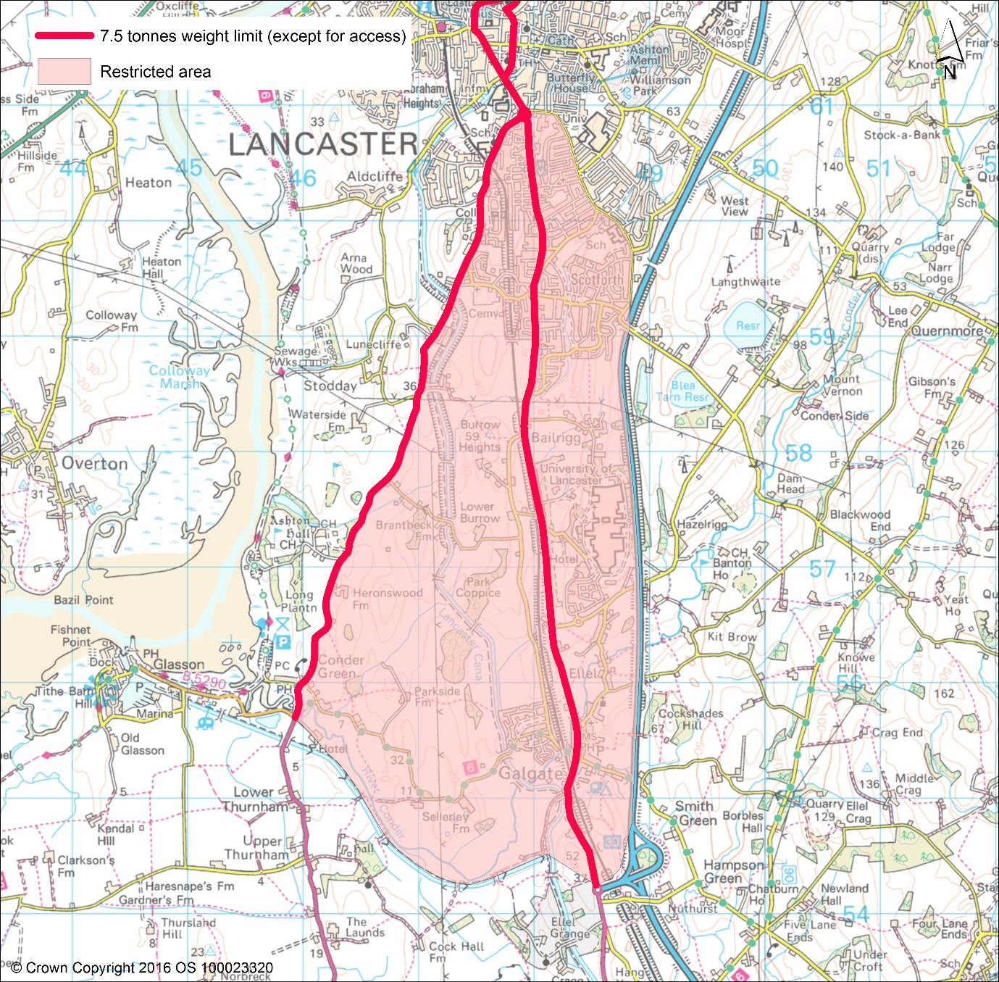
4.2 Lancaster Central (The City Centre Gyratory including the Lune bridges and Morecambe Road)
The existing main route to Morecambe and Heysham from the M6 for HGVs is via Junction 34. HGVs enter the Lancaster gyratory systems along Caton Road before continuing to Morecambe and Heysham via Morecambe Road. Caton Road also provides access to a number of major industrial estates (Lansil and Riverside Park), which include significant distribution depots generating HGV movements.
The two gyratory systems are one way with multiple access points and lie at the convergence of five main corridors: the A6 (Slyne Road) from the north, the A683 (Caton Road) from the north east, the A6 (Greaves Road) and A588 (Ashton Road) from the south, which meet at Pointer Roundabout, and the A683 (Morecambe Road) from the west. The city centre gyratory system encircles the main shopping area, severing it from several of the city's historic public realm features such as Dalton Square, Queen Square and most notably Lancaster Castle, and the main railway station.

Within the gyratory systems are two river crossings: Greyhound Bridge for westbound traffic and Skerton Bridge for eastbound traffic. Greyhound Bridge is currently the main gateway for traffic movements from Lancaster to Morecambe and Heysham, with traffic continuing along the A683 (Morecambe Road).

4.2.1 Link Road Benefits
It has been estimated that the new Link Road will reduce traffic around the main city centre gyratory by up to 10% and that a significant amount of this will be HGVs. Whilst this is not a significant reduction, coupled with managing Lancaster's approaches, it does present an opportunity to begin the process of eliminating congestion from the city centre. This is a key longer-term objective of the draft Lancaster District Highways and Transport masterplan.
In addition, the anticipated reduction in traffic using Caton Road as a result of the opening of the Heysham to M6 Link Road presents an opportunity to promote Caton Road as the principal gateway for traffic approaching Lancaster city centre from the M6. The draft Lancaster District Highways and Transport Masterplan proposes that a series of complementary measures including Park and Ride/cycle parking provision at M6 Junction 34, improvements for local journeys on the A6 south of the city and a future reprioritisation of the local highway network, will enable the Caton Road to be utilised as a managed approach to traffic in the city centre.
4.2.2 Access Issues
Whilst the link road will remove the need for traffic to utilise the river crossing gyratory as a through route to Morecambe and Heysham, the city centre gyratory will remain the only practical route to service the many businesses and institutions within the city centre and adjacent areas. In this regard access for HGVs that service this area will need to be maintained.
4.2.3 Recommendations
It is proposed to restrict HGVs from using the gyratory as a through route onwards to Morecambe and Heysham through imposition of a 7.5 tonne weight limit prior to Greyhound Bridge and at the left turn onto Parliament Street. Access will be maintained for HGVs to service businesses and institutions on and within the Lancaster city centre gyratory and the Luneside Industrial estate. Map 2 shows indicative lines in relation to weight limits and the wider restricted area.
Map 2.

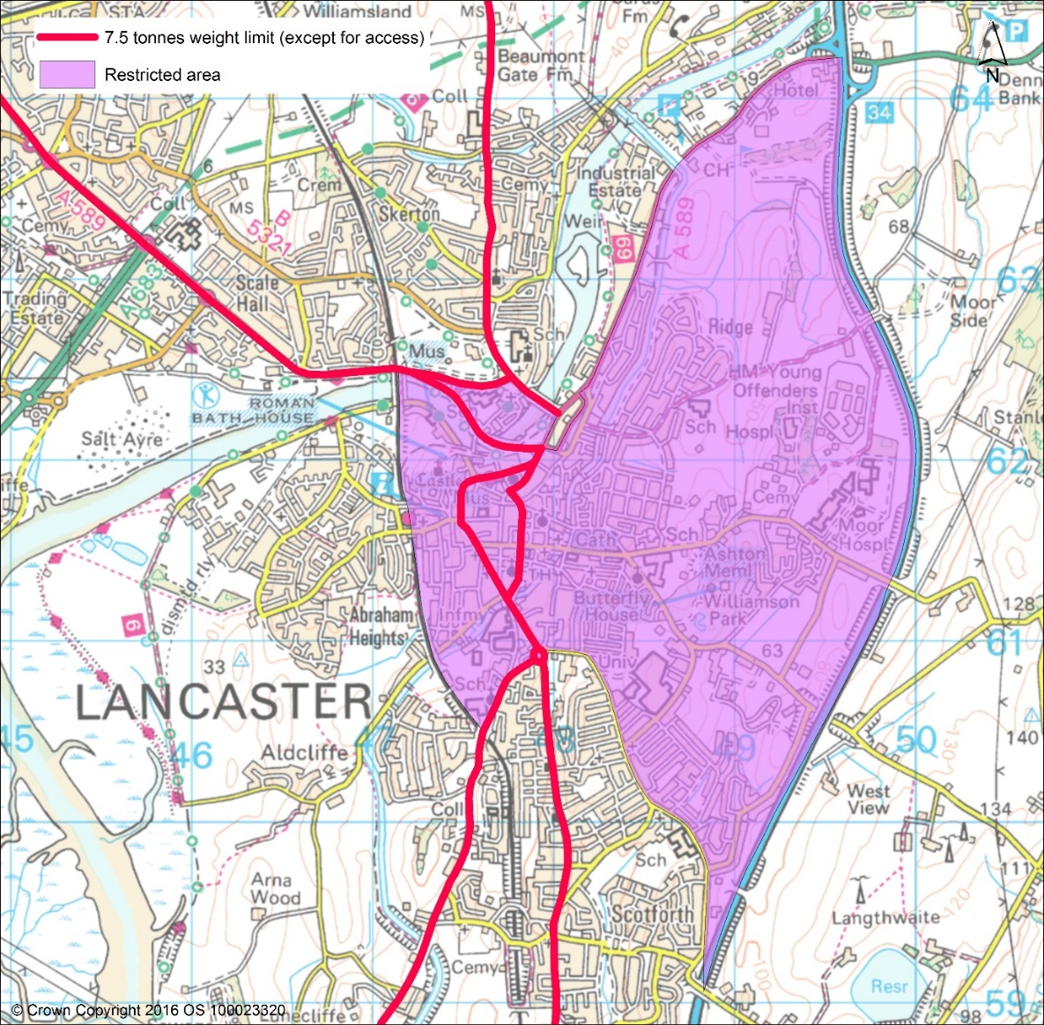

4.3 Carnforth, Bolton-le-Sands and North Lancaster (M6 Junction 35, A6 north via Carnforth and Skerton to Lancaster)
Currently, the signed route for HGV traffic accessing Morecambe from the north exits the M6 at Junction 35. This has a significant impact on the urban environment of Carnforth, particularly in the town centre at the crossroads between the A6 and Market Street, where at peak periods standing traffic often extends back to the A601 (M) from the north and towards Bolton-le-Sands from the south. Carnforth town centre is a designated Air Quality Management Area due to significant congestion; HGVs also pass through the town centre on route to both Morecambe and Lancaster along the A6.
The draft Lancaster and Highways and Transport Masterplan outlines a programme of pedestrian and traffic management improvements in the centre of Carnforth, focusing on Market Street, with a view to creating a space which, whilst allowing traffic to flow, is far more user friendly for those on foot or on bicycle. It also aims to implement measures to make the shopping area more attractive.
4.3.1 Link Road Benefits
With traffic to Morecambe directed to Junction 34, there will be benefits to Carnforth and there are associated improvements proposed as highlighted above. There will also be improvements on the A6 to the north of Lancaster, particularly through Skerton. The new link road will provide access to and from the A6 between Slyne and Skerton.
4.3.2 Access Issues
There are access requirements in terms of HGVs serving Carnforth as there are a small number of industrial and distribution developments within the area. There is also a major truck rest stop, Truckhaven, on the A6 immediately south of the A601(M). On the A6 between Bolton-le-Sands and Skerton there are relatively few requirements in terms of HGV access. There will be a new junction from the link road onto the A6.
4.3.3 Recommendations
It is proposed to limit HGV access along the A6 from the Truckhaven lorry park south of the A601(M) other than for access to Carnforth. This will be implemented through a 7.5 tonne weight limit restriction except for access along the A6 from Truckhaven to Skerton Bridge. Map 3 shows indicative lines in relation to weight limits and the wider restricted area for Carnforth, Bolton-le-Sands and North Lancaster.

Map 3
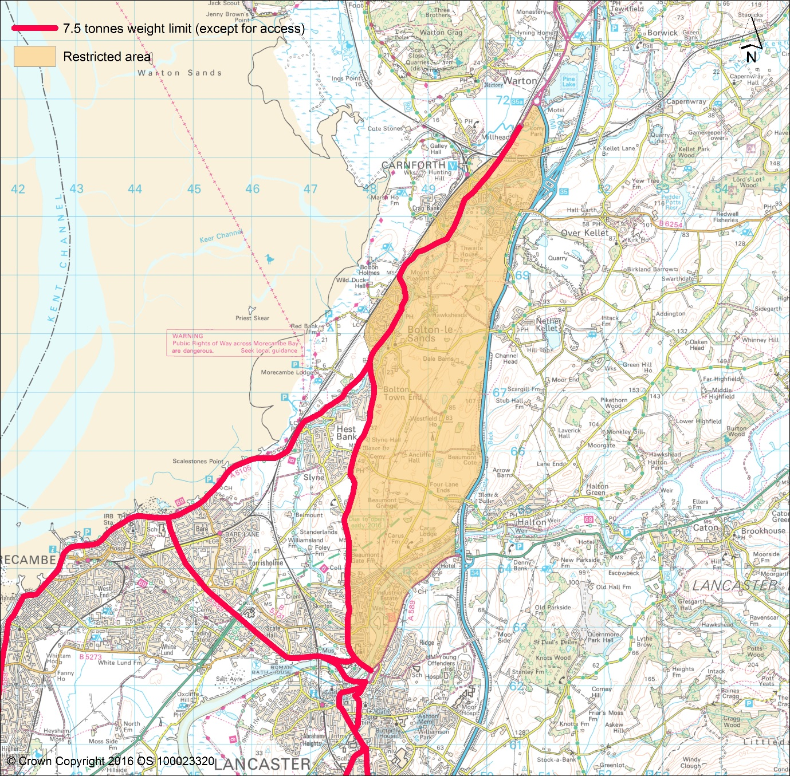

4.4 Morecambe and Heysham (M6 Junction 35, A6 north via Carnforth and A5105 to Morecambe and Heysham)
Once through Carnforth, HGVs heading to Morecambe pass through Bolton-le-Sands before taking the A5105 Coastal Road. This has an impact on the main residential areas of Hest Bank, Morecambe promenade and much of Heysham.
4.4.1 Link Road Benefits
The draft Lancaster District Highways and Transport Masterplan sets out a variety of measures that will build on the potential the new link road offers to deliver wider improvements by moving traffic away from urban areas. The masterplan outlines a place-shaping programme for Morecambe. Elements of this programme seek to better assimilate the seafront into the Morecambe urban realm and a significant component of this is reducing traffic to make the promenade area a place predominantly for people, not vehicles. Better management of traffic and particularly HGVs can contribute significantly to this aspiration.
4.4.1 Access Issues
There are very little in terms of access requirements for HGVs serving Torrisholme and Bare. Access to the White Lund Industrial Estate will be improved via the new link road
4.3.3 Recommendations
It is proposed to restrict HGV access along the A5105 and the A589. This will be implemented through a 7.5 tonne weight limit restriction except for access along the A5105 and A589 from the junction with the A6 to the A683 roundabout at Heysham and from Greyhound Bridge along Morecambe Road. Map 4 shows indicative lines in relation to the proposed restrictions.

Map 4
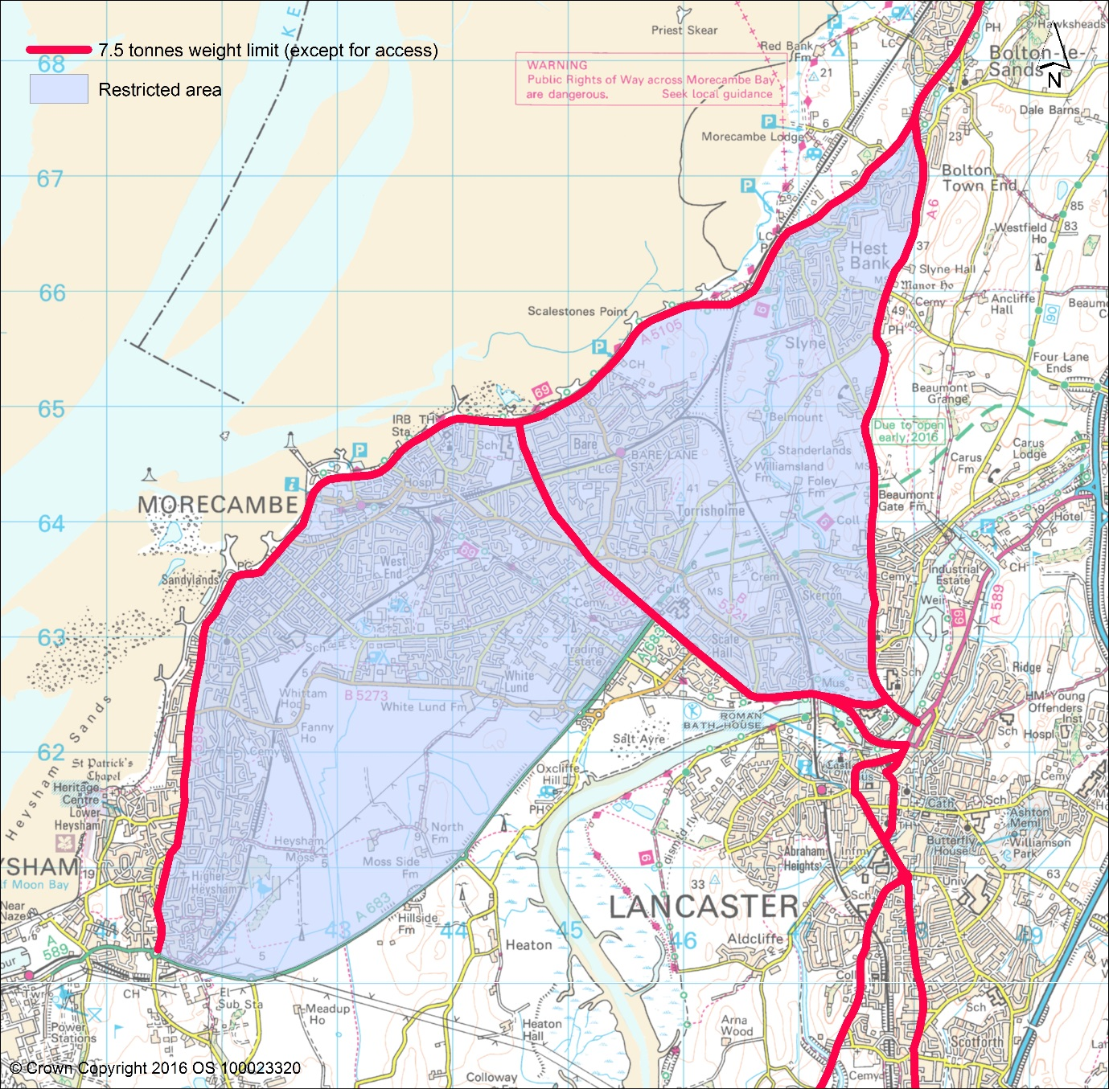

- Diversionary Routes
A diversionary route in the case of closure of the M6 is operational through Lancaster. Currently this utilises the A6 between J33 and J34. Between J34 and J36 the A683 and A65 via Kirkby Lonsdale are utilised. Any recommendations presented in this strategy will accommodate the need for an appropriate diversionary route network. Further to this, in line with this strategy the County Council will work with Highways England to review these diversionary routes and determine whether in light of the link road opening current diversionary routes are still the most suitable. Any review of diversionary routes will need to acknowledge that any weight limit restrictions would need to be temporarily lifted if there is an incident on the M6 requiring traffic to be diverted.
- Abnormal Loads
Abnormal loads are loads that are wider, taller or heavier than the normal maximum allowed on roads in the UK. If the load can be split, it must be, but if the load is a single indivisible load, then there is a legal provision for the load to travel subject to notification of the route and in many cases, with an escort. Abnormal loads may have to be routed on alternative routes through Lancaster in order to avoid certain structures or physical restrictions, or if there is a diversionary route implemented from the M6. Given an established network of routes exists in relation to the management of abnormal loads within Lancaster District, it should be noted that this restricts the type of traffic management measures that could be implemented on routes that may be subject to weight limits to ensure enforcement, for example, localised narrowing of the carriageway.
- Enforcement
Any subsequent Traffic Regulation Orders (TROs) implemented as a result of this strategy will be subject to enforcement. Currently, enforcement of TROs is undertaken by the Police. However, evidence from around the country shows that in some cases local authorities have taken over this responsibility from the Police, and that advances in new technology, such as registration plate recognition cameras, for example, can also play an effective role in the enforcement process. These elements will be reviewed as part of a wider assessment of the implementation and application of the subsequent TROs.
- Recommendations
Map 5 shows the network wide recommendations. It illustrates the wider areas that the 7.5 weight tonne restriction will affect as well as showing both the restricted and non-restricted routes. This will pave the way for subsequent Traffic Regulation Orders measures.

Map 5
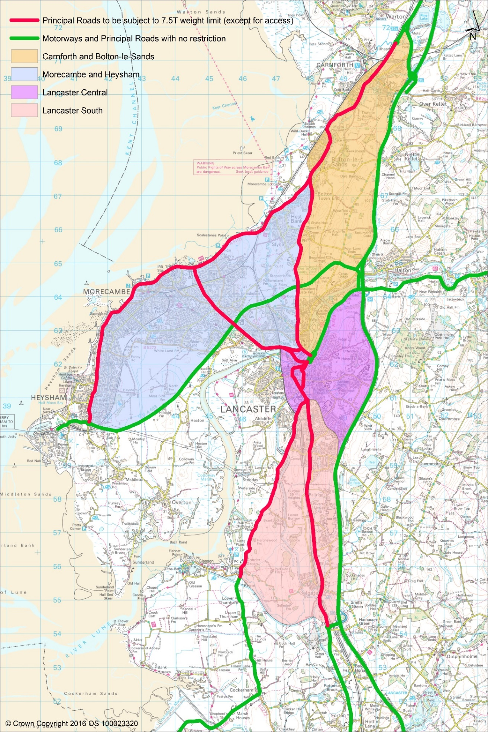

Appendices
Appendix 1: Motorways and Principal Roads with no restrictions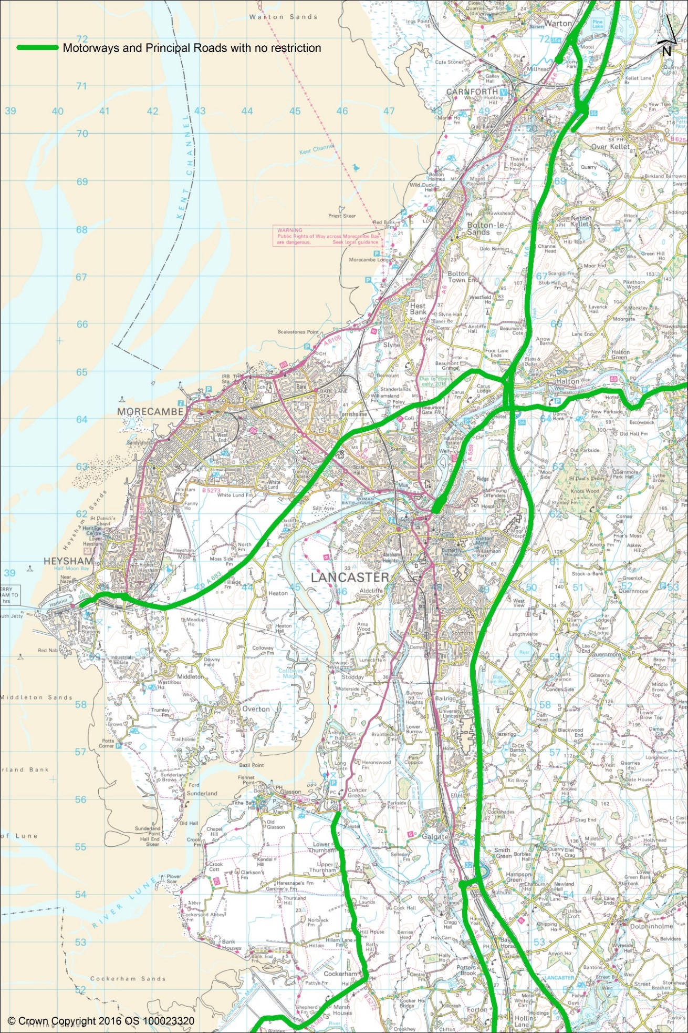
Appendix 2: Principal Roads to be subjected to 7.5 tonnes weight limit (except for access)
